School of Integrated Technology, Yonsei University

Course: Special Topics in System Engineering

Homework 1
due date: before class on the 17th March
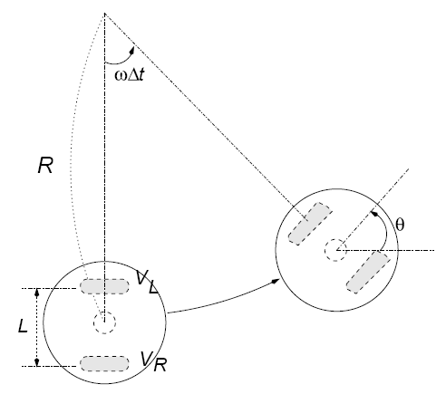

Figure 1. Robot system and kinematics in simulation

The robot is positioned at (x0, y0) and now the robot has the wheel speeds, the left wheel speed VL, the right wheel speed VR. Using the curved motion with a radius R and angular speed w, derive an equation to get a new robot position (x,y) and the head direction of the robot (refer to Figure 1).

Submit a 1-page handout to show the position of a wheeled robot.

